**IEEE SRM SB R&D DOMAIN**

**SECTION – 1**

1. **What machine learning algorithm is suitable for this graph?**

A logistic regression model

1. 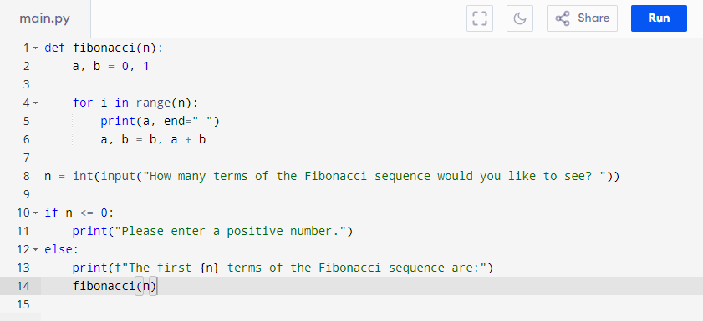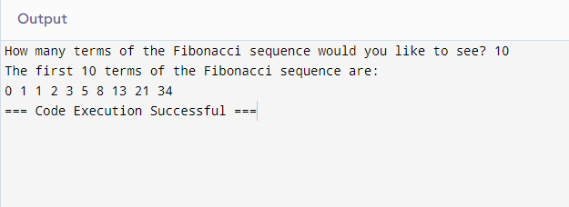
2. **Which of the following data structures uses a First In First Out (FIFO) approach?**

Answer : Queue

1. **Which of the following is a valid variable name in Python?**

Answer : **variable_1**

1. **Which of the following sorting algorithms is considered the fastest in average case?**

Answer : Merge Sort